Scenic Valley Farms 2022 Willamette Valley
Ramato of Pinot Gris


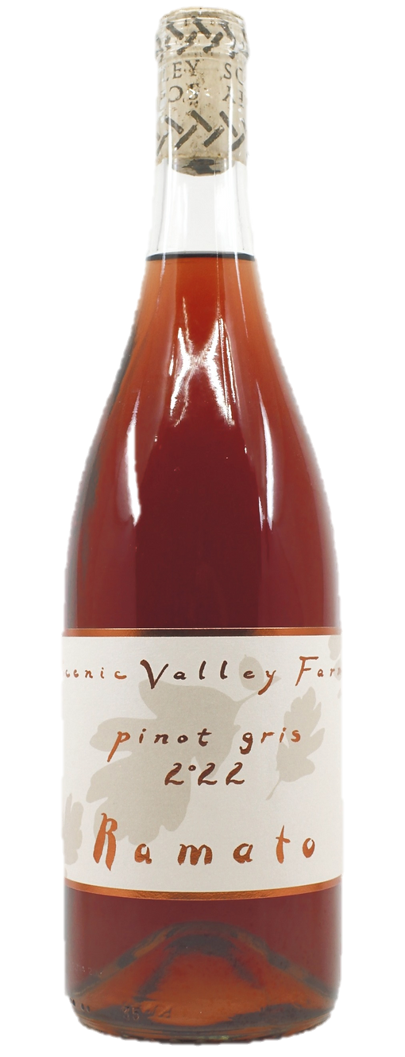



An outstanding and compelling pink wine made in a Ramato style that raises the bar for rosé intensity and depth. Intense amaro-like flavours of mountain herbs and flowers, with wild dill, anise, and thyme combined with notes of preserved lemons, ginger root, and sasparilla.
Drinking Window: 2024 - 2030

