**Scenic Valley Farms 2023 Pinot Noir**

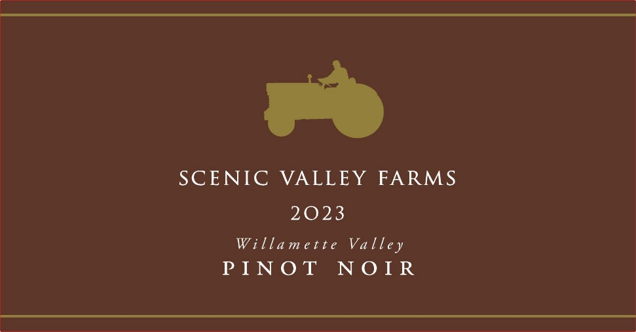 **Cases**: 2150

**AVA**: Willamette Valley

**Technical Data**:

**pH** – 3.58

**RS -** <1 g/L

**Alcohol** – 12.9%

**BRIX at Harvest** - 21-24

**Cooperage:** 15% new Oregon oak, 90% neutral oak, 10 months in barrel

**Vineyards**: 70% Hare Vineyard, 25% Silvershot, 5% Illahe

**Tasting Notes**: A vibrant pinot with bright red flavors of raspberry and strawberry. While packed with flavor, the delicate texture dances across the palate with style and grace. Forestry earthy undertones provide depth and estate harvested Oregon oak gives this wine structure.

**Winemaking Notes**: A shining example of a beautiful vintage that produced elegant wines with depth and complexity. This Pinot Noir is also a reflection of our vineyard crew, which handles all the pruning, vine training, and harvesting by hand. Our cool climate site always gives us low alcohol, high acid wines, so we blend it with fruit from two of our friends’ vineyards to create balance. Wild fermented for added complexity, barrel aged in Oregon oak for ten months to create depth and filtered to ensure it is stable and consistent for years to come.

**Vintage Notes**: A long cold winter led to a late budbreak at the very end of April, but a heat wave in May allowed the vines to catch up quickly. Sporadic fall rain created a tricky vintage, with dry periods for harvesting grapes mixed with rainy periods that forced us to take a break from harvesting but allowed us to focus on processing the juice in the cellar. As we like to say at Scenic Valley, these long slow harvests are the most difficult, but they make the most interesting wines.